Students’ Handout C# Chapter-1

Welcome to the C# in ASP.NET Core training session on creating a job portal application! This handout provides guidelines for students on how to approach the material, participate in workshops, and complete exercises. The topics covered in this section include console applications, variables, data types, control structures, arrays, and enums. Please follow the guidelines below for an optimal learning experience.

As for the exercises, you have to complete the pending 80% of the work that we provide.

**Exercise 1:**

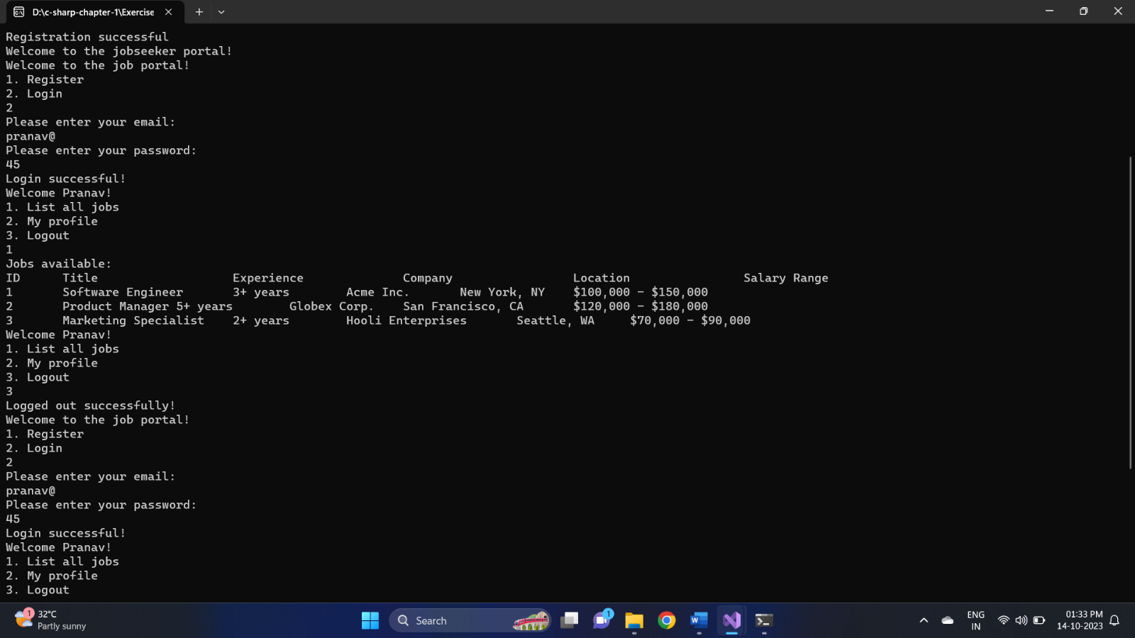

Create a console application where we can register as job seekers and then log in using our email and password. Later, after logging in show a menu option asking us whether to list all jobs or display our profile or log out.

You have been given a framework to work with. Please let us know if you need any assistance in completing it.